Nepal College of Information Technology
Assessment Exam
Level: Bachelor Year : 2013
Programme: BE ( Com/ IT) Full Marks : 100
Course: Numerical Methods Time : 3hrs.

Candidates are required to give their answers in their on words as far as practicable. The figures in the margin indicate full marks.
Attempt All questions.

1. | a. | Find the root of the equation 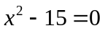 with accuracy 0.008, using False Position method. | 8
 | b. | Calculate the root of non-linear equation 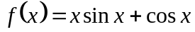using Newton Raphson method correct to 4 significant digits. | 7
2. | a. | Use appropriate method of interpolation to get 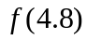 from given table. | 8
  x | 1 | 2 | 3 | 4 | 5 | 6
  F(x) | 4 | 7.5 | 4 | 8.5 | 9.6 | 11
 | b. | Use the suitable method to fit a second order polynomial from following data: | 7
  x | -3 | -2 | -1 | 0 | 1 | 2 | 3
  y | 4.63 | 2.11 | 0.67 | 0.09 | 0.63 | 2.15 | 4.56
3. | a. | Evaluate the integral 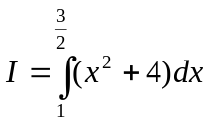, Compare the result in both conditions for Gaussian 2 point and 3 point formula. | 10
 | b. | The following data gives corresponding values of pressure ‘P’ and specific volume ‘V’ of steam engine.  Find the rate of change of volume when pressure is 25.3. | 5
  P | 105 | 42.7 | 25.3 | 16.7 | 13
  V | 2 | 4 | 6 | 8 | 10

4. | a.  b. | Using power method, find the largest Eigen value of the following matrix. 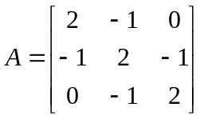  Solve the following linear equation by Gauss Seidal method.  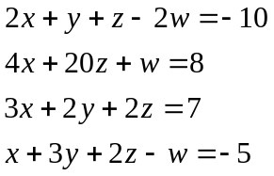 | 8  7
5. | a. | Solve the following differential equation within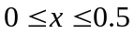 using RK 4th order method. 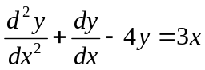, with 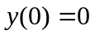and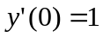. (take h=0.25) | 8
 | b. | Solve the Poission equation 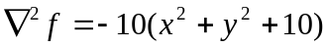, over the square domain of 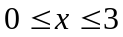 and 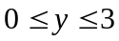 with 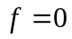 and 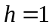 | 7
6. | a. | Solve the differential equation 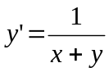 using Advanced Eulers method within 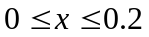with 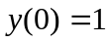 | 8
 | b. | Use the suitable method and determine the exponential fit of 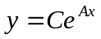for the following data: | 7
  X | 1 | 2 | 3 | 4 | 5
  Y | 1.2 | 2.5 | 6.25 | 15.75 | 28.65
7. |  | Write short notes on (Any Two) (5×2) | 10
 | a. | Errors in Numerical Methods
 | b. | Convergence/divergence of FPI method.
 | c. | Pivoting Techniques.

